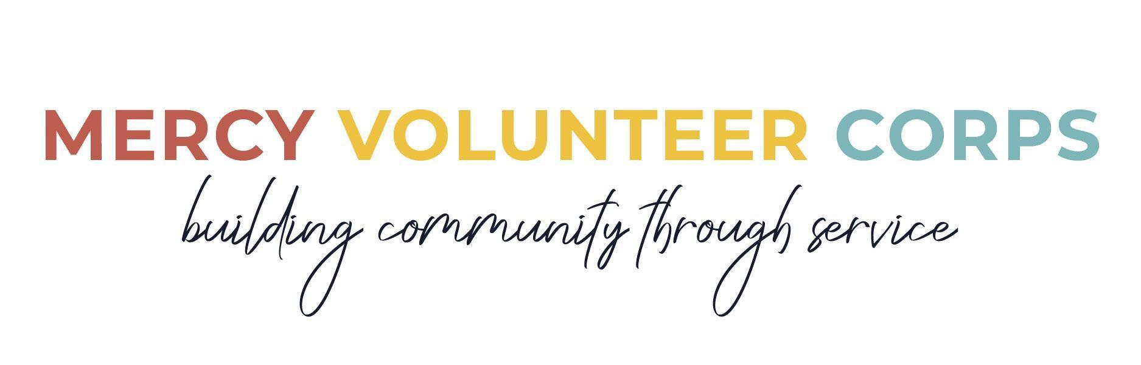

SHORT-TERM PLACEMENT POSITION DESCRIPTION

SERVICE SITE: ARISE Adelante (Alamo, Texas)
POSITION TITLE: Summer Camp Leader
COMMITMENT: Wednesday, June 3 - Saturday, July 18, 2026

SITE DESCRIPTION
Located in the southernmost part of Texas bordering Mexico, ARISE Adelante serves families who live among fifty colonias within the Rio Grande Valley. Supported by nearly 30 staff members and four community centers, ARISE is a community-based program that is run by, for and with the people of each of the communities it serves. These communities, called "colonias," are economically impoverished, but are working together to improve life for their neighbors and their families. Each summer, ARISE invites volunteers from outside of the local area to join its mission by providing six weeks of learning and fun for children and leadership development for youth during their summer break from school.
Website: ariseadelante.org/

PRIMARY VOLUNTEER DUTIES
- Work with a team of volunteers to plan and lead educational and social activities for children and youth of various ages
- Work with children and youth in small groups while encouraging their personal and social development
- Engage and collaborate with ARISE community volunteers as well as visiting school groups in providing a safe and welcoming environment and meaningful experience

QUALIFICATIONS
- Enjoy working with children and youth ages 3-18
- Comfortable leading group activities and working collaboratively with others
- Openness, patience and flexibility, both in the work and cross-cultural setting

WORK SCHEDULE
Weekdays 8:30 am-6:00 pm with an extended afternoon break for lunch, relaxation, and enrichment experiences. The summer camp is held 9:00-11:00 am and 4:00-6:00 pm weekdays.

ENVIRONMENT & ATTIRE
It is hot and humid in southern Texas in the summer with temperatures regularly in the 90s during the day. This is the reason for an extended afternoon break. Wear hats/bandanas, sun block and light breathable clothing. The centers do not have air conditioning. It can be very dusty when the wind is blowing and at times there are many mosquitoes.

BENEFITS
- Room and board provided, along with a living stipend of $400
- Community vehicle available and transportation costs covered within the Rio Grande Valley
- Travel expenses to and from Alamo, TX covered up to $500
- Provides a cross-cultural, educational experience through meeting with community members and better understanding the realities of the border and issues related to immigration
- Participation in community life and shared reflection with other volunteers and the local Mercy community

